# Principle and operation of Single Phase Transformer

# A transformer is a static device that transfers electric power in one circuit to another circuit of the same frequency.

# A [transformer](https://www.elprocus.com/what-is-a-potential-transformer-construction-types-its-applications/) is a device which converts magnetic energy into electrical energy.

# It consists of primary and secondary windings. This transformer operates on the principle of mutual inductance.

# The primary [winding](https://www.elprocus.com/motor-winding-and-its-types/) of a transformer receives power, while the secondary winding delivers power.

# A magnetic iron circuit called “core” is commonly used to wrap around these coils. Though these two coils are electrically isolated, they are magnetically linked.

# Based on how the windings are wound around the central steel laminated core, the transformer construction is divided into two types

# 

# Core-type Transformer

# In this type of construction, only half of the windings are wound cylindrically around each leg of a transformer to enhance magnetic coupling as shown in the figure below.

# This type of construction ensures that magnetic lines of force flow across both the windings simultaneously.

# The main disadvantage of the core-type transformer is the leakage flux that occurs due to the flow of a small proportion of magnetic lines of force outside the core

# 

# Shell-type Transformer

# In this type of transformer construction, the primary and secondary windings are positioned cylindrically on the center limb resulting in twice the cross-sectional area than the outer limbs.

# There are two closed magnetic paths in this type of construction and the outer limb has the magnetic flux ɸ/2 flowing. Shell type transformer overcomes leakage flux, reduces core losses and increases efficiency

# 

# Principle of Single Phase Transformer

# The single-phase transformer works on the principle of [Faraday’s Law of Electromagnetic Induction](https://www.elprocus.com/electromagnetic-induction-and-laws/). Typically, mutual induction between primary and secondary windings is responsible for the transformer operation in an electrical transformer.

# 

# Working of Single Phase Transformer

# When the primary of a transformer is connected to an AC supply, the current flows in the coil and the magnetic field build-up.

# This condition is known as mutual inductance and the flow of current is as per the Faraday’s Law of electromagnetic induction. As the current increases from zero to its maximum value, the magnetic field strengthens and is given by dɸ/dt.

# This electromagnet forms the magnetic lines of force and expands outward from the coil forming a path of magnetic flux.

# The turns of both windings get linked by this magnetic flux

# The strength of a magnetic field generated in the core depends on the number of turns in the winding and the amount of current

# The magnetic flux and current are directly proportional to each other.

# EMF equation of the Transformer

# Let, N1 = Number of turns in primary winding N2 = Number of turns in secondary winding Φm = Maximum flux in the core (in Wb) = (Bm x A) f = frequency of the AC supply (in Hz)

# As, shown in the fig., the flux rises sinusoidally to its maximum value Φm from 0. It reaches to the maximum value in one quarter of the cycle i.e in T/4 sec (where, T is time period of the sin wave of the supply = 1/f).

# Therefore, average rate of change of flux = Φm /(T/4)    = Φm /(1/4f) Therefore, average rate of change of flux = 4f Φm       ....... (Wb/s).

# 

# Now, Induced emf per turn = rate of change of flux per turn

# Therefore, average emf per turn = 4f Φm   ..........(Volts).

# Now, we know,  Form factor = RMS value / average value Therefore, RMS value of emf per turn = Form factor X average emf per turn. As, the flux Φ varies sinusoidally, form factor of a sine wave is 1.11 Therefore, RMS value of emf per turn =  1.11 x 4f Φm = 4.44f Φm. RMS value of induced emf in whole primary winding (E1) = RMS value of emf per turn X Number of turns in primary winding           E1 = 4.44f N1 Φm          ............................. eq 1

# Similarly, RMS induced emf in secondary winding (E2) can be given as

# E2 = 4.44f N2 Φm.          ............................ eq 2 from the above equations 1 and 2,

# This is called the emf equation of transformer, which shows, emf / number of turns is same for both primary and secondary winding. For an [ideal transformer](https://www.electricaleasy.com/2014/03/ideal-transformer-characteristics.html) on no load, E1 = V1 and E2 = V2 . where, V1 = supply voltage of primary winding             V2 = terminal voltage of secondary winding

# 

# Losses in a Transformer

# An ideal transformer is the one which is 100% efficient.

# This means that the power supplied at the input terminal should be exactly equal to the power supplied at the output terminal, since efficiency can only be 100%

# if the output power is equal to the input power with zero energy losses.

# But in reality, nothing in this universe is ever ideal.

# Similarly, since the output power of a transformer is never exactly equal to the input power, due a number of electrical losses inside the core and windings of the transformer, so we never get to see a 100% efficient transformer.

# Transformer is a static device, i.e. we do not get to see any movements in its parts, so no mechanical losses exist in the transformer and only electrical losses are observed.

# So there are two primary types of electrical losses in the transformer:

# 1. Copper losses

# 2. Iron losses

# Other than these, some small amount of power losses in the form of ‘stray losses’ are also observed, which are produced due to the leakage of magnetic flux.

# Copper losses

# These losses occur in the windings of the transformer when heat is dissipated due to the current passing through the windings and the internal resistance offered by the windings.

# So these are also known as ohmic losses or I2R losses,

# where ‘I’ is the current passing through the windings and

# R is the internal resistance of the windings.

# These losses are present both in the primary and secondary windings of the transformer and depend upon the load attached across the secondary windings

# since the current varies with the variation in the load, so these are variable losses.

# Mathematically, these copper losses can be defined as:

# Pohmic = I2pRp + I2sRs

# Iron losses

# These losses occur in the core of the transformer and are generated due to the variations in the flux.

# These losses depend upon the magnetic properties of the materials which are present in the core, so they are also known as iron losses,

# as the core of the Transformer is made up of iron. And since they do not change like the load, so these losses are also constant losses.

# There are two types of Iron losses in the transformer:

# 1. Eddy Current losses

# 2. Hysteresis Loss

# Eddy Current Losses

# When an alternating current is supplied to the primary windings of the transformer,

# it generates an alternating magnetic flux in the winding which is then induced in the secondary winding also through Faraday’s law of electromagnetic induction,

# and is then transferred to the externally connected load. During this process, the other conduction materials of which the core is also gets linked with this flux and an emf is induced.

# But this magnetic flux does not contribute anything towards the externally connected load or the output power and is dissipated in the form of heat energy.

# So such losses are called Eddy Current losses and are mathematically expressed as:

# Pe = Ke f² Kf² Bm²

# Where; Ke = Constant of Eddy Current

# Kf² = Form Constant

# Bm = Strength of Magnetic Field

# Hysteresis Loss

# Hysteresis loss is defined as the electrical energy which is required to realign the domains of the ferromagnetic material which is present in the core of the transformer.

# These domains loose their alignment when an alternating current is supplied to the primary windings of the transformer and the emf is induced in the ferromagnetic material of the core which disturbs the alignment of the domains and afterwards they do not realign properly.

# For their proper realignment, some external energy supply, usually in the form of current is required. This extra energy is known as Hysteresis loss.

# Mathematically, they can be defined as;

# Ph = Kh Bm1.6 fV

# These are the different kinds of losses happened to occur in transformer

# VOLTAGE REGULATION AND EFFICIENCY OF TRANSFORMER

# Voltage Regulation

# The voltage regulation is defined as the change in the magnitude of receiving and sending voltage of the transformer.

# The voltage regulation determines the ability of the transformer to provide the constant voltage for variable loads.

# The electrical equipments are designed to be operated at a certain voltage.

# A tolerance limit is provided so that equipment may operate between this range.

# Transformers connect equipments and machines to the supply. If the terminal voltage drops too low below the rated value due to the load currents, it may affect the performance of the equipments. This is not desirable.

# It is therefore important to specify and quantify that there is a voltage drop when certain load current is taken up from the transformer.

# Voltage regulation is quantified using two terms:

# a.       Regulation down

# b.      Regulation up

# Regulation Down

# Regulation down is the change in terminal voltage when a load current at any power factor is applied, expressed as a fraction of the no-load terminal voltage.

# http://ecoursesonline.iasri.res.in/pluginfile.php/3689/mod_resource/content/1/Lesson%2013_files/image001.png

# Where, Vnl = no-load terminal voltage Vl =  load terminal voltage

# Regulation Up

# Regulation up is the ratio of the change in the terminal voltage when a load at a given power factor is removed, and the load voltage.

# Where, Vnl = no-load terminal voltage. Vl = load voltage.

# http://ecoursesonline.iasri.res.in/pluginfile.php/3689/mod_resource/content/1/Lesson%2013_files/image002.png

# Efficiency of Transformer

# Just like any other electrical machine, efficiency of a transformer can be defined as the output power divided by the input power.

# i.e. efficiency = output / input .

# Transformers are the most highly efficient electrical devices.

# Most of the transformers have full load efficiency between 95% to 98.5% .

# As a transformer being highly efficient, output and input are having nearly same value, and hence it is impractical to measure the efficiency of transformer by using output / input.

# A better method to find efficiency of a transformer is using,

# efficiency = (input - losses) / input

# = 1 - (losses / input).

# Condition for maximum efficiency

# Let, Copper loss = I12R1 ,

# Iron loss = Wi

# Hence,

# efficiency of a transformer will be maximum when copper loss and iron losses are equal. That is Copper loss = Iron loss.

# https://2.bp.blogspot.com/-vPFBtCslCIk/Uz1Ld8zvH-I/AAAAAAAAArs/HTMe4G_BwC0/s1600/efficiency+of+transformer.png

# All day efficiency of transformer

# As we have seen above, ordinary or commercial efficiency of a transformer can be given as

# But in some types of transformers, their performance can not be judged by this efficiency.

# efficiency of transformer

# For example, distribution transformers have their primaries energized all the time. But, their secondaries supply little load all no-load most of the time during day (as residential use of electricity is observed mostly during evening till midnight).

# That is, when secondaries of transformer are not supplying any load (or supplying only little load), then only core losses of transformer are considerable and copper losses are absent (or very little).

# Copper losses are considerable only when transformers are loaded. Thus, for such transformers copper losses are relatively less important.  The performance of such transformers is compared on the basis of energy consumed in one day.

# All day efficiency of a transformer is always less than ordinary efficiency of it.

# https://4.bp.blogspot.com/-EiA6-K0l3s8/U05QLxA2k0I/AAAAAAAAAwY/KgdUAtGVTBE/s1600/all+day+efficiency+transformer.png

# Open and Short Circuit Test of Transformer

# Open and short circuit tests are performed on a transformer to determine the:

# [Equivalent circuit of transformer](https://www.electrical4u.com/equivalent-circuit-of-transformer-referred-to-primary-and-secondary/)

# [Voltage regulation of transformer](https://www.electrical4u.com/voltage-regulation-of-transformer/)

# [Efficiency of transformer](https://www.electrical4u.com/voltage-regulation-of-transformer/)

# The power required for open circuit tests and short circuit tests on a transformer is equal to the power loss occurring in the transformer.

# Open Circuit Test on Transformer

# The connection diagram for open circuit test on transformer is shown in the figure.

# A [voltmeter](https://www.electrical4u.com/working-principle-of-voltmeter-and-types-of-voltmeter/), [wattmeter](https://www.electrical4u.com/electrodynamometer-type-wattmeter/), and an [ammeter](https://www.electrical4u.com/ammeter/) are connected in LV side of the transformer as shown.

# The [voltage](https://www.electrical4u.com/voltage-or-electric-potential-difference/) at rated frequency is applied to that LV side with the help of a variac of variable ratio [auto transformer](https://www.electrical4u.com/what-is-auto-transformer/).

# The HV side of the transformer is kept open.

# Now with the help of variac, applied voltage gets slowly increased until the voltmeter gives reading equal to the rated voltage of the LV side.

# After reaching rated LV side voltage, we record all the three instruments reading (Voltmeter, Ammeter and Wattmeter readings).

# 

# The ammeter reading gives the no load current Ie. As no load current Ie is quite small compared to rated [current](https://www.electrical4u.com/electric-current-and-theory-of-electricity/) of the [transformer](https://www.electrical4u.com/what-is-transformer-definition-working-principle-of-transformer/), the [voltage drops](https://www.electrical4u.com/voltage-drop-calculation/) due to this current that can be taken as negligible.

# Since voltmeter reading V1 can be considered equal to the secondary induced voltage of the transformer,

# [wattmeter](https://www.electrical4u.com/electrodynamometer-type-wattmeter/) reading indicates the input power during the test.

# As the transformer is open circuited, there is no output, hence the input power here consists of core [losses in transformer](https://www.electrical4u.com/hysteresis-eddy-current-iron-or-core-losses-and-copper-loss-in-transformer/) and copper loss in transformer during no load condition.

# But as said earlier, the no-load current in the transformer is quite small compared to the full load current so, we can neglect the copper loss due to the no-load current.

# Hence, can take the wattmeter reading as equal to the core losses in the transformer.

# Short Circuit Test on Transformer

# 

# The connection diagram for the short circuit test on the transformer is shown in the figure below.

# A voltmeter, wattmeter, and an ammeter are connected in HV side of the transformer as shown.

# A low voltage of around 5-10% is applied to that HV side with the help of a variac (i.e. a variable ratio [auto transformer](https://www.electrical4u.com/what-is-auto-transformer/)).

# We short-circuit the LV side of the transformer. Now with the help of variac applied voltage is slowly increased until the [wattmeter](https://www.electrical4u.com/electrodynamometer-type-wattmeter/), and an [ammeter](https://www.electrical4u.com/ammeter/) gives reading equal to the rated current of the HV side.

# After reaching the rated current of the HV side, we record all the three instrument readings ([Voltmeter](https://www.electrical4u.com/working-principle-of-voltmeter-and-types-of-voltmeter/), Ammeter and Watt-meter readings).

# The ammeter reading gives the primary equivalent of full load current IL.

# As the voltage applied for full load current in a short circuit test on the transformer is quite small compared to the rated primary voltage of the transformer, the core [losses in the transformer](https://www.electrical4u.com/hysteresis-eddy-current-iron-or-core-losses-and-copper-loss-in-transformer/) can be taken as negligible here.

# Let’s say, voltmeter reading is Vsc. The watt-meter reading indicates the input power during the test.

# As we have short-circuited the transformer, there is no output; hence the input power here consists of copper losses in the transformer.

# Since the applied voltage Vsc is short circuit voltage in the transformer and hence it is quite small compared to the rated voltage, so, we can neglect the core loss due to the small applied [voltage](https://www.electrical4u.com/voltage-or-electric-potential-difference/).

# Hence the wattmeter reading can be taken as equal to copper losses in the transformer. Let us consider wattmeter reading is Psc.

# Where, Re is equivalent [resistance](https://www.electrical4u.com/electrical-resistance-and-laws-of-resistance/) of transformer.

# Hence the short-circuit test of a transformer is used to determine copper losses in the transformer at full load

# 

# Auto Transformer

# An Auto Transformer is a transformer with only one winding wound on a laminated core.

# An auto transformer is similar to a two winding transformer but differ in the way the primary and secondary winding are interrelated.

# A part of the winding is common to both primary and secondary sides.

# On load condition, a part of the load current is obtained directly from the supply and the remaining part is obtained by transformer action.

# An Auto transformer works as a voltage regulator.

# In an ordinary transformer, the primary and the secondary windings are electrically insulated from each other but connected magnetically as shown in the figure below.

# 

# While in auto transformer the primary and the secondary windings are connected magnetically as well as electrically.

# In fact, a part of the single continuous winding is common to both primary and secondary.

# There are two types of auto transformer based on the construction.

# In one type of transformer, there is continuous winding with the taps brought out at convenient points determined by the desired secondary voltage.

# However, in another type of auto transformer, there are two or more distinct coils which are electrically connected to form a continuous winding. The construction of Auto transformer is shown in the figure below.

# The primary winding AB from which a tapping at C is taken, such that CB acts as a secondary winding

# The supply voltage is applied across AB, and the load is connected across CB.

# The tapping may be fixed or variable. When an AC voltage V1 is applied across AB, an alternating flux is set up in the core, as a result, an emf E1 is induced in the winding AB.

# A part of this induced emf is taken in the secondary circuit

# Let,

# V1 – primary applied voltage

# V2 – secondary voltage across the load

# I1 – primary current

# I2 – load current

# N1 – number of turns between A and B

# N2 – number of turns between C and B

# Neglecting no-load current, leakage reactance and losses,

# V1 = E1 and V2 = E2

# Therefore, the transformation ratio:

# As the secondary ampere-turns are opposite to primary ampere-turns, so the current I2 is in phase opposition to I1.

# The secondary voltage is less than the primary. Therefore current I2 is more than the current I1.

# Therefore, the resulting current flowing through section BC is (I2 – I1).

# 

# The ampere-turns due to section BC = current x turns

# 

# Equation (1) and (2) shows that the ampere-turns due to section BC and AC balance each other which is characteristic of the transformer action.

# Saving of Copper in Auto Transformer as Compared to Ordinary Two Winding Transformer

# The weight of the copper is proportional to the length and area of a cross-section of the conductor.

# The length of the conductor is proportional to the number of turns, and the cross-section is proportional to the product of current and number of turns.

# Now, from the above figure (B) shown of the auto transformer, the weight of copper required in an auto transformer is

# Wa = weight of copper in section AC + weight of copper in section CB

# Therefore

# If the same duty is performed with an ordinary two winding transformer shown above in the figure (A), the total weight of the copper required in the ordinary transformer,

# 

# W0 = weight of copper on its primary winding + weight of copper on its secondary winding

# Therefore

# ,

# Now, the ratio of the weight of the copper in an auto transformer to the weight of copper in an ordinary transformer is given as

# 

# Saving of copper affected by using an auto transformer = weight of copper required in an ordinary transformer – weight of copper required in an auto transformer

# Therefore,

# Saving of copper = K x weight of copper required for two windings of the transformer

# Hence, saving in copper increases as the transformation ratio approaches unity. Hence the auto transformer is used when the value of K is nearly equal to unity.

# 

# Three Phase InductionMotor

The most common type of AC motor being used throughout the work today is the "Induction Motor". Applications of three-phase induction motors of size varying from half a kilowatt to thousandsofkilowattsarenumerous.Theyarefoundeverywherefromasmallworkshoptoalarge manufacturingindustry.

The advantages of three-phase AC induction motor are listed below:

* Simpledesign
* Ruggedconstruction
* Reliableoperation
* Low initialcost
* Easy operation and simplemaintenance
* Simple control gear for starting and speedcontrol
* Highefficiency.

Induction motor is originated in the year 1891 with crude construction (The induction machine principle was invented by *NIKOLA TESLA* in 1888.). Then an improved construction with distributed stator windings and a cage rotor was built.

The slip ring rotor was developed after a decade or so. Since then a lot of improvement has taken place on the design of these two types of induction motors. Lot of research work has been carried out to improve its power factor and to achieve suitable methods of speed control.

# Types and Construction of Three Phase InductionMotor

Three phase induction motors are constructed into two major types:

1. Squirrel cage InductionMotors
2. Slip ring InductionMotors

*Squirrel cage InductionMotors*

## StatorConstruction

The induction motor stator resembles the stator of a revolving field, three phase alternator. The statororthestationarypartconsistsofthreephasewindingheldinplaceintheslotsofalaminated steel core which is enclosed and supported by a cast iron or a steel frame as shown in Fig:3.1(a).

The phase windings are placed 120 electrical degrees apart and may be connected in either staror deltaexternally,forwhichsixleadsarebroughtouttoaterminalboxmountedontheframeofthe motor.Whenthestatorisenergizedfromathree-phase voltageitwillproducearotatingmagnetic field in the statorcore.

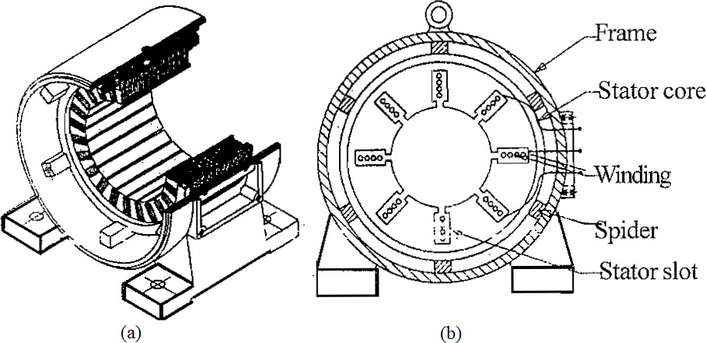

## RotorConstruction

The rotor of the squirrel cage motor shown in Fig: 3.1(b) contains no windings. Instead it is a cylindricalcoreconstructedofsteellaminationswithconductorbarsmountedparalleltotheshaft and embedded near the surface of the rotorcore.

These conductor bars are short circuited by an end rings at both end of the rotor core. In large machines, these conductor bars and the end rings are made up of copper with the bars brazed or welded to the end rings shown in Fig: 3.1(b).In small machines the conductor bars and end rings aresometimesmadeofaluminiumwiththebarsandringscastinaspartoftherotorcore.Actually the entire construction (bars and end-rings) resembles a squirrel cage, from which the name is derived.

Therotororrotatingpartisnotconnectedelectricallytothepowersupplybuthasvoltageinduced in it by transformer action from the stator. For this reason, the stator is sometimes called the primary and the rotor is referred to as the secondary of the motor since the motor operates on the principle of induction and as the construction of the rotor with the bars and end rings resembles a squirrel cage, the squirrel cage induction motor isused.

The rotor bars are not insulated from the rotor core because they are made of metals having less resistance than the core. The induced current will flow mainly in them. Also the rotor bars are usually not quite parallel to the rotor shaft but are mounted in a slightly skewed position. This featuretendstoproduceamoreuniformrotorfieldandtorque.Alsoithelpstoreducesomeofthe internal magnetic noise when the motor isrunning.

1. EndShields

The function of the two end shields is to support the rotor shaft. They are fitted with bearings and attached to the stator frame with the help of studs or bolts attention.

*Slip ring InductionMotors*

## StatorConstruction

The construction of the slip ring induction motor is exactly similar to the construction of squirrel cage induction motor. There is no difference between squirrel cage and slip ring motors.

## RotorConstruction

The rotor of the slip ring induction motor is also cylindrical or constructed of lamination.

Squirrel cage motors have a rotor with short circuited bars whereas slip ring motors have wound rotors having "three windings" each connected in star.

The winding is made of copper wire. The terminals of the rotor windings of the slip ring motors are brought out through slip rings which are in contact with stationary brushes as shown in Fig.

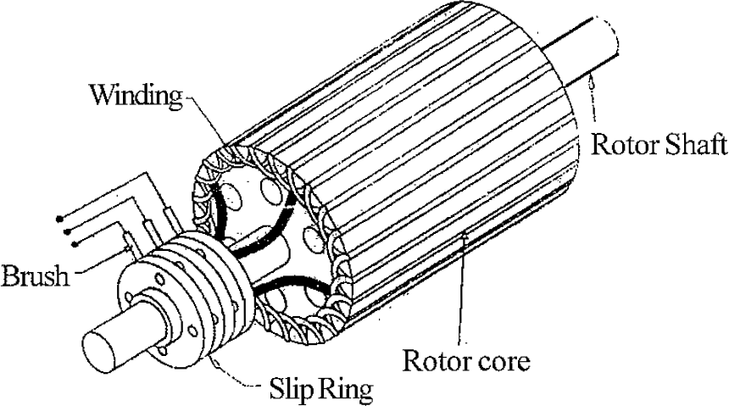

*THE ADVANTAGES OF THE SLIPRING MOTOR ARE*

* It has susceptibility to speed control by regulating rotorresistance.
* High starting torque of 200 to 250% of full loadvalue.
* Low starting current of the order of 250 to 350% of the full loadcurrent.

Hence slip ring motors are used where one or more of the above requirements are to be met.

## Comparison of Squirrel Cage and Slip RingMotor

|  |  |  |  |
| --- | --- | --- | --- |
| Sl.No. | Property | *Squirrel cage motor* | *Slip ring motor* |
| 1. | Rotor Construction | *Bars are used in rotor. Squirrel cage motor is very simple, rugged and long lasting. No slip rings and brushes* | *Winding wire is to be used.*  *Wound rotor required attention.*  *Slip ring and brushes are needed also need frequent maintenance.* |
| 2. | Starting | *Can be started by D.O.L., star-delta, auto*  *transformer starters* | *Rotor resistance starter is required.* |
| 3. | Starting torque | *Low* | *Very high* |
| 4. | Starting Current | *High* | *Low* |
| 5. | Speed variation | *Not easy, but could be varied in large steps by pole changing or through smaller incremental steps through thyristors or by frequency variation.* | *Easy to vary speed.*  *Speed change is possible by inserting rotor resistance using thyristors or by usingfrequency variation injecting emf in therotor*  *circuit cascading.* |
| 6. | Maintenance | *Almost ZERO maintenance* | *Requires frequent maintenance* |
| 7. | Cost | *Low* | *High* |

Principle ofOperation

The operation of a 3-phase induction motor is based upon the application of Faraday Law and the Lorentzforceonaconductor.Thebehaviourcanreadilybeunderstoodbymeansofthefollowing example.

Consider a series of conductors of length l, whose extremities are short-circuited by two bars A and B (Fig.3.3 a). A permanent magnet placed above this conducting ladder, moves rapidly tothe right at a speed v, so that its magnetic field B sweeps across the conductors. The following sequence of events then takesplace:

1. A voltage E = Blv is induced in each conductor while it is being cut by the flux (Faraday law).
2. The induced voltage immediately produces a current I, which flows down the conductor underneath the pole face, through the end-bars, and back through the otherconductors.
3. Becausethecurrentcarryingconductorliesinthemagneticfieldofthepermanentmagnet, it experiences a mechanical force (Lorentzforce).
4. Theforcealwaysactsinadirectiontodragtheconductoralongwiththemagneticfield.If the conducting ladder is free to move, it will accelerate toward the right. However, as it picks up speed, the conductors will be cut less rapidly by the moving magnet, with the result that the induced voltage E and the current I will diminish. Consequently, the force acting on the conductors wilt also decreases. If the ladder were to move at the same speed asthemagneticfield,theinducedvoltageE,thecurrentI,andtheforcedraggingtheladder along would all becomezero.

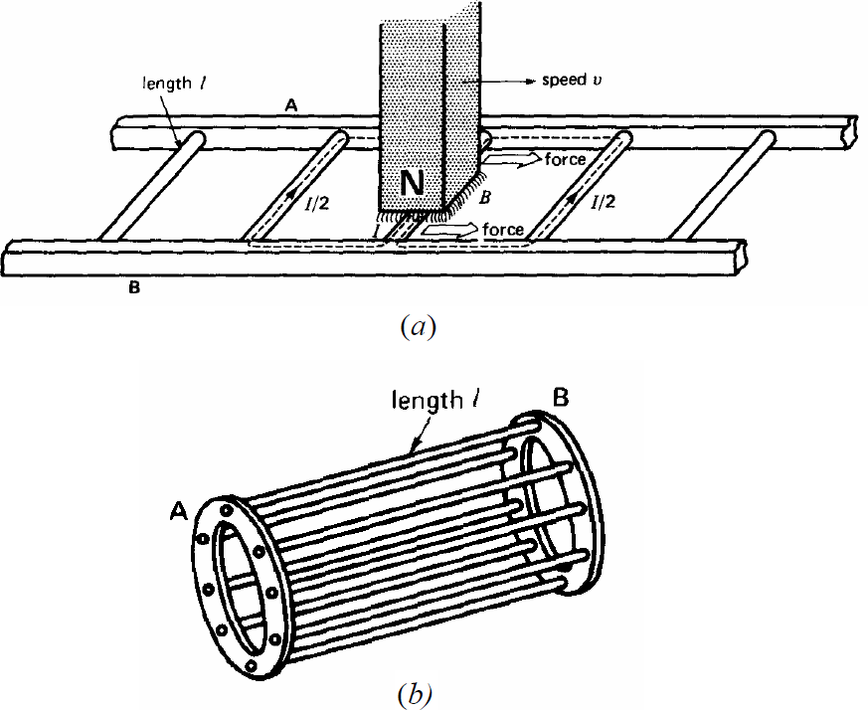

In an induction motor the ladder is closed upon itself to form a squirrel-cage (Fig.3.3b) and the moving magnet is replaced by a rotating field. The field is produced by the 3-phase currents that flow in the stator windings.

# Rotating Magnetic Field and InducedVoltages

Consider a simple stator having 6 salient poles, each of which carries a coil having 5 turns. Coils that are diametrically opposite are connected in series by means of three jumpers

that respectively connect terminals a-a, b-b, and c-c. This creates three identical sets of windings AN, BN, CN, which are mechanically spaced at 120 degrees to each other. The two coils in each winding produce magneto motive forces that act in the same direction.

Thethreesetsofwindingsareconnected inwye,thusformingacommonneutralN. Owingtothe perfectlysymmetricalarrangement,thelinetoneutralimpedancesareidentical.Inotherwords,as regards terminals A, B, C, the windings constitute a balanced 3-phasesystem.

For a two-pole machine, rotating in the air gap, the magnetic field (i.e., flux density) being sinusoidally distributed with the peak along the centre of the magnetic poles. The result is illustrated in Fig.3.5. The rotating field will induce voltages in the phase coils aa', bb', and cc'. Expressions for the induced voltages can be obtained by using Faraday laws of induction.

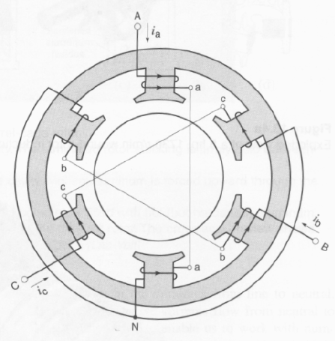

Fig: Elementary stator having terminals A, B, C connected to a 3-phase source (not shown).

Currents flowing from line to neutral are considered to be positive.

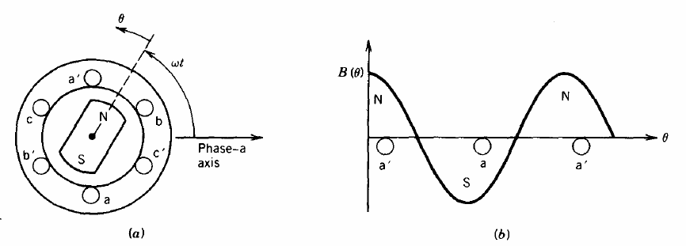

Fig: Air gap flux density distribution.

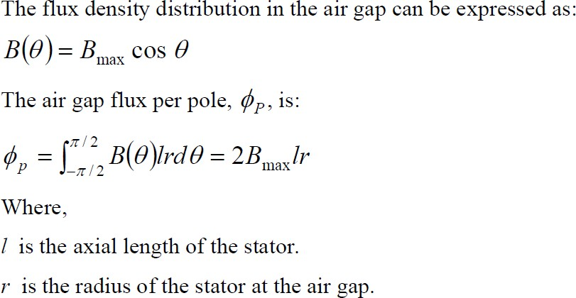

Let us consider that the phase coils are full-pitch coils of N turns (the coil sides of each phase are 180 electrical degrees apart as shown in Fig.3.5). It is obvious that as the rotating field moves (or the magnetic poles rotate) the flux linkage of a coil will vary. The flux linkage for coil aa' will be maximum.

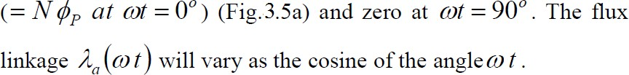

Hence,

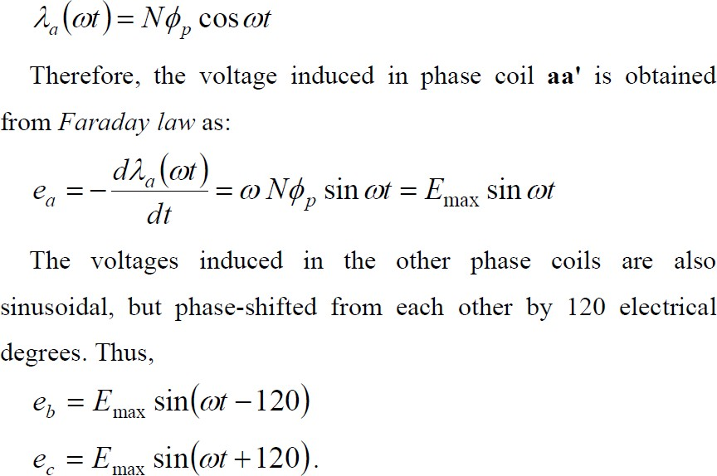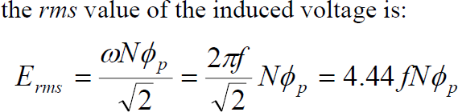

Wherefisthefrequencyinhertz.Aboveequationhasthesameformasthatfortheinducedvoltage in transformers. However, ØP represents the flux per pole of themachine.

Theaboveequationalsoshowsthermsvoltageperphase.TheNisthetotalnumberofseriesturns perphasewiththeturnsformingaconcentratedfull-pitchwinding.InanactualACmachineeach phase winding is distributed in a number of slots for better use of the iron and copper and to improve the waveform. For such a distributed winding, the EMF induced in various coils placed in different slots are not in time phase, and therefore the phasor sum of the EMF is less than their numerical sum when they are connected in series for the phase winding. A reduction factor KW, called the winding factor, must therefore be applied. For most three-phase machine windings KW is about 0.85 to0.95.

Therefore, for a distributed phase winding, the rms voltage per phase is

*Erms = 4.44fNphφpKW*

Where *Nph*is the number of turns in series per phase.

# Speed of rotating magneticfield

The speed at which the rotating magnetic field revolves is called the synchronous speed (Ns). Referring to Fig. 3.6 (ii), the time instant 4 represents the completion of one-quarter cycle of alternating current Ix from the time instant 1. During this one quarter cycle, the field has rotated through 90°. At a time instant represented by 13 [Fig. 3.6 (ii)] or one complete cycle of current Ix fromtheorigin,thefieldhascompletedonerevolution.Therefore,fora2-polestatorwinding,the fieldmakesonerevolutioninonecycleofcurrent.Ina4-polestatorwinding,itcanbeshownthat therotatingfieldmakesonerevolutionintwocyclesofcurrent.Ingeneral,furPpoles,therotating field makes one revolution in P/2 cycles ofcurrent.

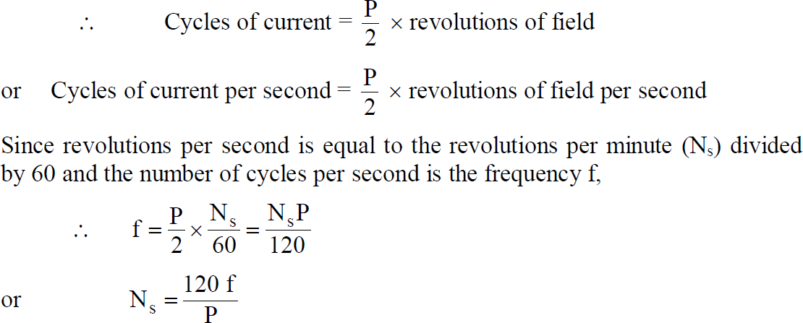

Thespeedoftherotatingmagneticfieldisthesameasthespeedofthealternatorthatissupplying power to the motor if the two have the same number of poles. Hence the magnetic flux is said to rotate at synchronousspeed.

# Direction of rotating magneticfield

The phase sequence of the three-phase voltage applied to the stator winding in Fig, is X- Y-Z. If this sequence is changed to X-Z-Y, it is observed that direction of rotation of the field is reversed i.e., the field rotates counter clockwise rather than clockwise. However, the number of poles and the speed at which the magnetic field rotates remain unchanged. Thus it is necessary only to change the phase sequence in order to change the direction of rotation of

the magnetic field. For a three-phase supply, this can be done by interchanging any two of the three lines. As we shall see, the rotor in a 3-phase induction motor runs in the same direction as the rotating magnetic field. Therefore, the direction of rotation of a 3-phase induction motor can be reversed by interchanging any two of the three motor supply lines.

# Slip

Wehaveseenabovethatrotorrapidlyacceleratesinthedirectionofrotatingfield.Inpractice,the rotor can never reach the speed of stator flux. If it did, there would be no relative speed between the stator field and rotor conductors, no induced rotor currents and, therefore, no torque to drive the rotor. The friction and windage would immediately cause the rotor to slow down. Hence, the rotor speed (N) is always less than the suitor field speed (Ns). This difference in speed depends upon load on the motor. The difference between the synchronous speed Ns of the rotating stator field and the actual rotor speed N is called slip. It is usually expressed as a percentage of synchronous speedi.e.

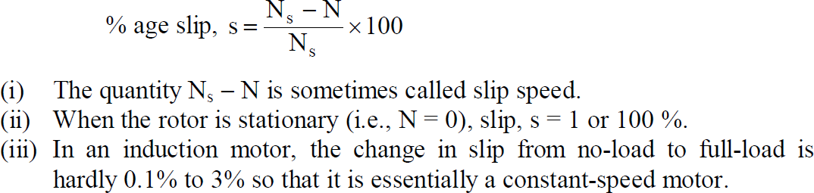

# Rotor CurrentFrequency

The frequency of a voltage or current induced due to the relative speed between a vending and a magnetic field is given by the generalformula;

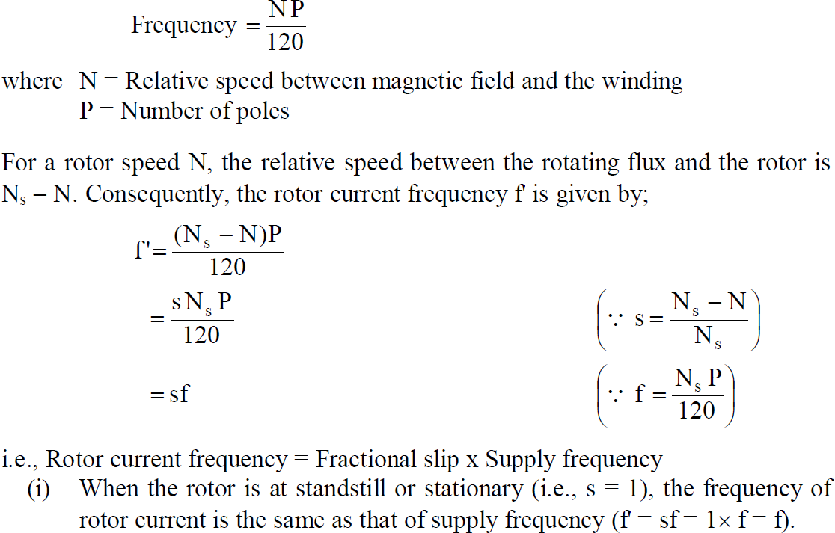

(ii) As the rotor picks up speed, the relative speed between the rotating flux and the rotor decreases. Consequently, the slip s and hence rotor current frequency decreases.

Power and Torque Relations of Three Phase InductionMotor

The transformer equivalent circuit of an induction motor is quite helpful in analyzing the various powerrelationsinthemotor.Fig.3.13showstheequivalentcircuitperphaseofaninductionmotor where all values have been referred to primary (i.e.,stator).

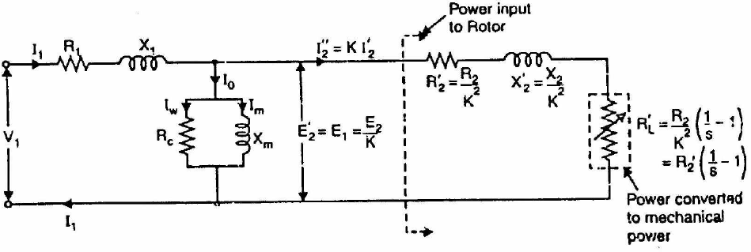

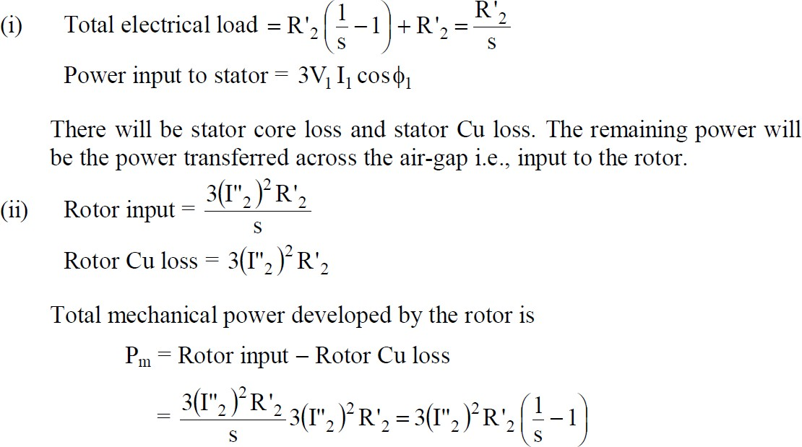

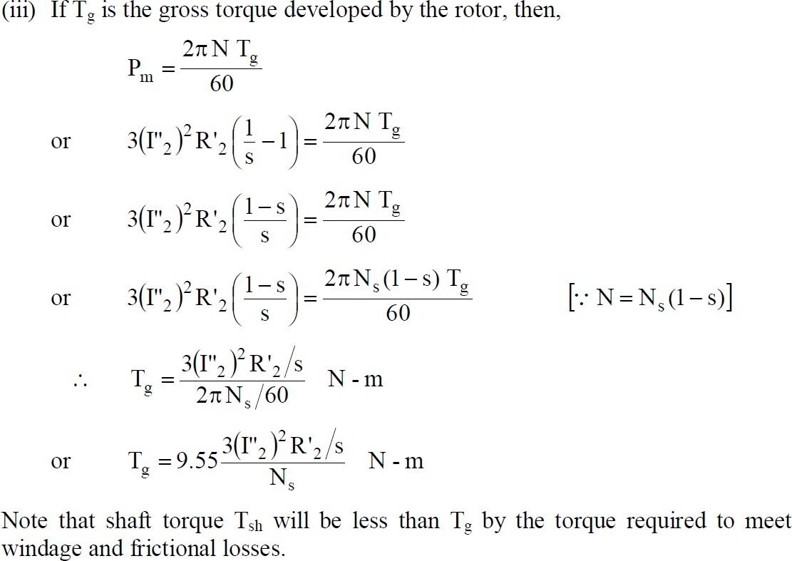

# Induction MotorTorque

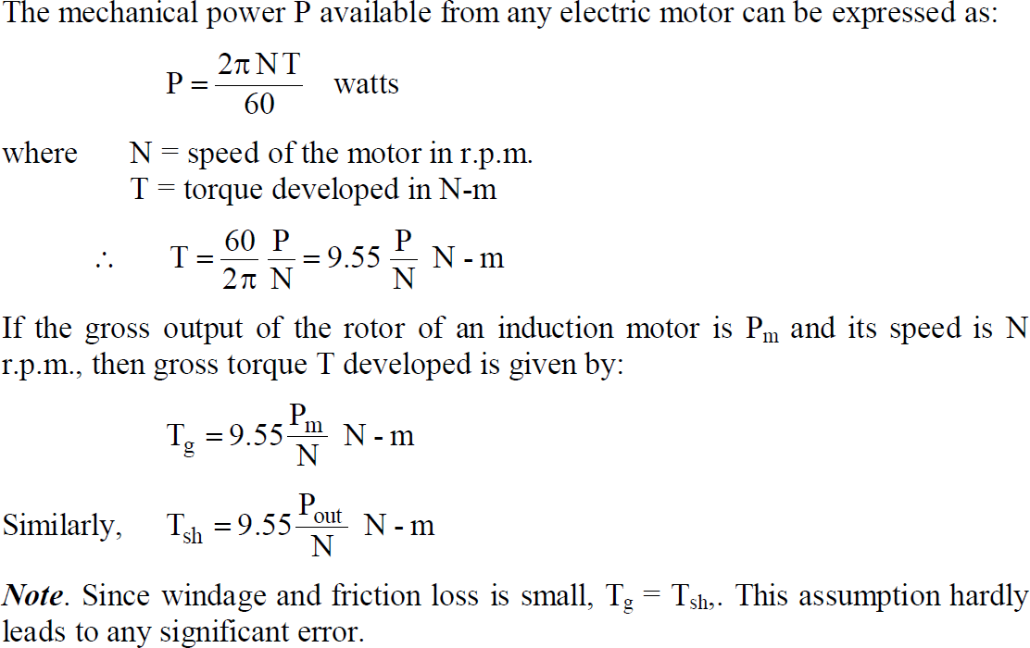

RotorOutput

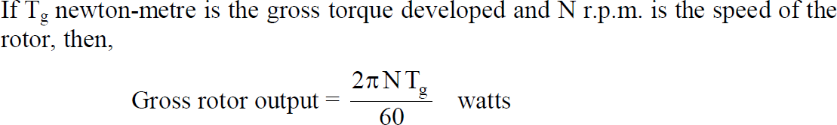

If there were no copper losses in the rotor, the output would equal rotor input and the rotor would run at synchronous speed Ns.

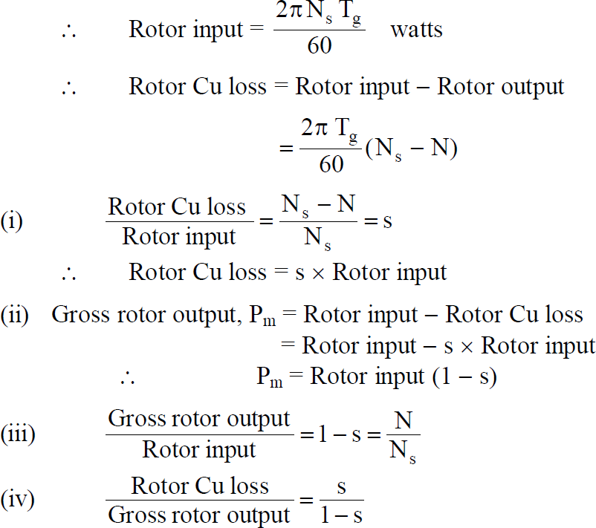

Itisclearthatiftheinputpowertorotoris“Pr”then“s.Pr”islostasrotorCulossandtheremaining (1 - s) Pr is converted into mechanical power. Consequently, induction motor operating at high slip has poorefficiency.

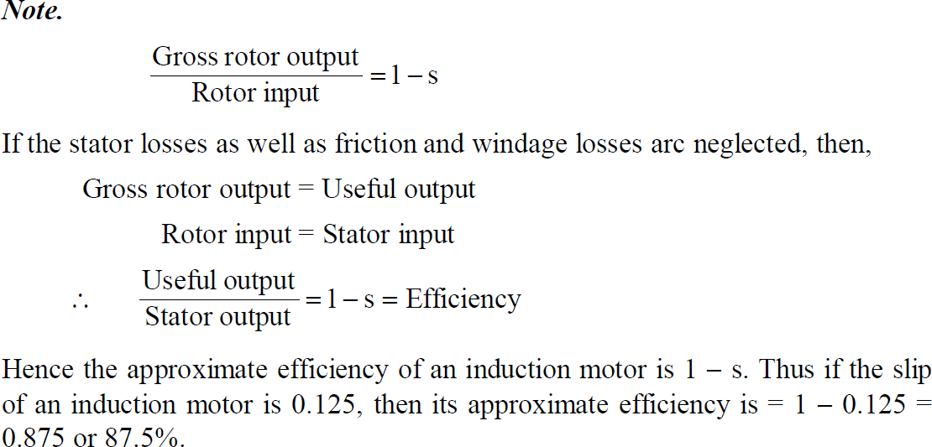

# TorqueEquations

The gross torque Tg developed by an induction motor is given by;

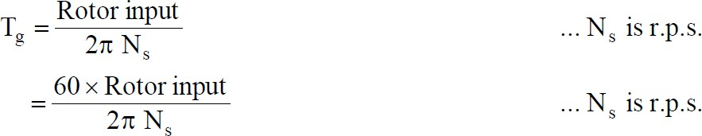

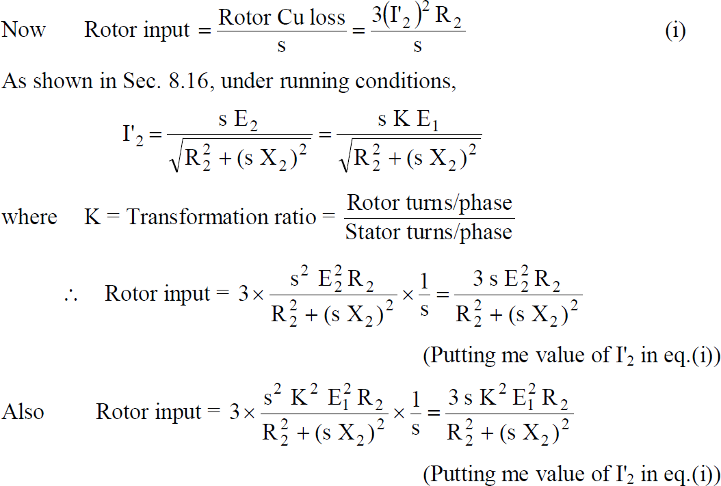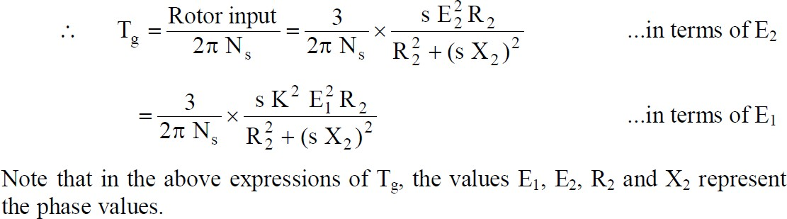

# RotorTorque

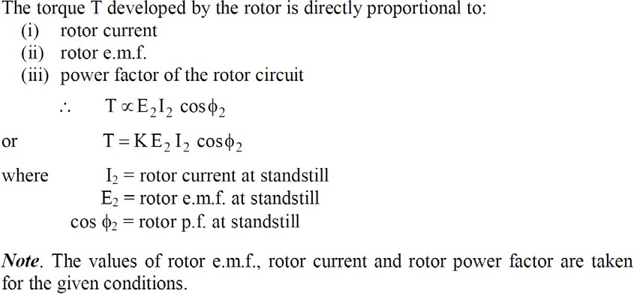

Starting Torque(Ts)

Let,

E2 = rotor e.m.f. per phase at standstill

X2 = rotor reactance per phase at standstill R2 = rotor resistance per phase

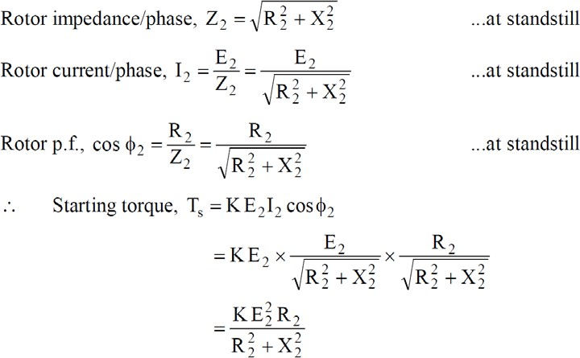

Generally, the stator supply voltage V is constant so that flux per pole  set up by the stator is also fixed. This in turn means that e.m.f. E2 induced in the rotor will be constant.

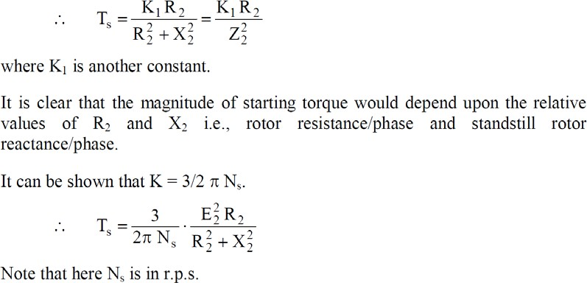

# Condition for Maximum StartingTorque

It can be proved that starting torque will be maximum when rotor resistance/phase is equal to standstill rotor reactance/phase.

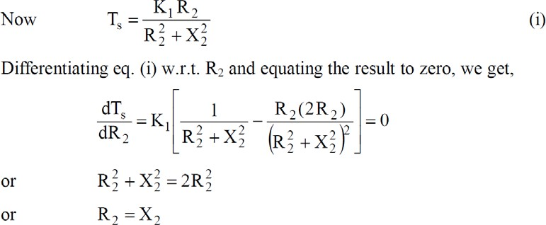

Hence starting torque will be maximum when:

*Rotor resistance/phase = Standstill rotor reactance/phase*

Under the condition of maximum starting torque, 2 = 45° and rotor power factor is 0.707 lagging.

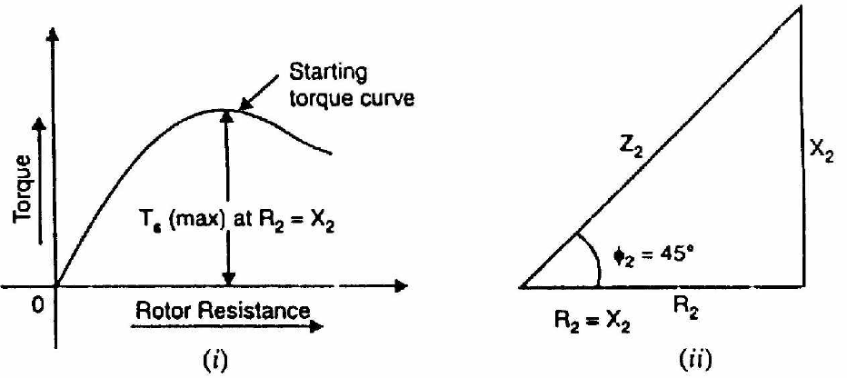

Fig. shows the variation of starting torque with rotor resistance. As the rotor resistance is increased from a relatively low value, the starting torque increases until it becomes maximum when R2 = X2. If the rotor resistance is increased beyond this optimum value, the starting torque will decrease.

# Effect of Change of SupplyVoltage

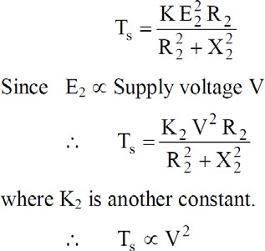

Therefore, the starting torque is very sensitive to changes in the value of supply voltage. For example, a drop of 10% in supply voltage will decrease the starting torque by about 20%. This couldmeanthemotorfailingtostartifitcannotproduceatorquegreaterthantheloadtorqueplus frictiontorque.

# Performance Characteristics of Three phase InductionMotor

The equivalent circuits derived in the preceding section can be used to predict the performance characteristics of the induction machine. The important performance characteristics in the steady state are the efficiency, power factor, current, starting torque, maximum (or pull-out) torque.

# The complete torque-speedcharacteristic

In order to estimate the speed torque characteristic let us suppose that a sinusoidal voltage is impressed on the machine. Recalling that the equivalent circuit is the per-phase representation of the machine, the current drawn by the circuit is given by

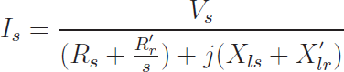

Where, Vs is the phase voltage phasor and Is is the current phasor. The magnetizing current is neglected. Since this current is flowing through R′r/s, the air-gap power is given by

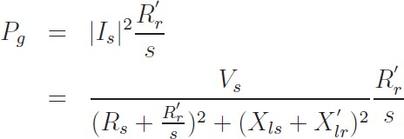

The mechanical power output was shown to be (1−s)Pg (power dissipated in R′r/s). The torque is obtained by dividing this by the shaft speed .Thus we have,

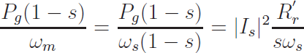

where is the synchronous speed in radians per second and s is the slip. Further, this is the torque produced per phase. Hence the overall torque is givenby

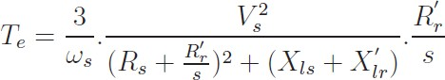

Thetorquemaybeplottedasafunctionof‘s’andiscalledthetorque-slip(ortorque-speed,since slip indicates speed) characteristic a very important characteristic of the inductionmachine.

A typical torque-speed characteristic is shown in Fig. This plot corresponds to a 3 kW, 4 pole, and 60 Hz machine. The rated operating speed is 1780 rpm.

Further, this curve is obtained by varying slip with the applied voltage being held constant. Coupled with the fact that this is an equivalent circuit valid under steady state, it implies that if thischaracteristicistobemeasuredexperimentally,weneedtolookatthetorqueforagivenspeed after all transients have died down. One cannot, for example, try to obtain this curve by directly starting the motor with full voltage applied to the terminals and measuring the torque and speed dynamically as it runs up to steadyspeed.

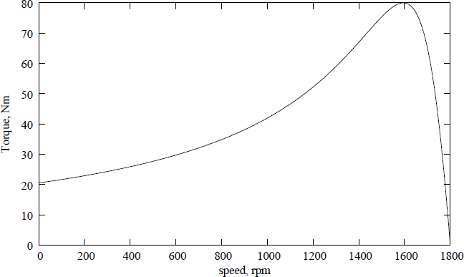

Withrespecttothedirectionofrotationoftheair-gapflux,therotormaybedriventohigherspeeds byaprimemoverormayalsoberotatedinthereversedirection.Thetorque-speedrelationforthe machine under the entire speed range is called the complete speed-torque characteristic. Atypical curveisshowninFig:3.19forafour-polemachine,thesynchronousspeedbeing1500rpm.Note that negative speeds correspond to slip values greater than 1, and speeds greater than 1500 rpm correspond to negative slip. The plot also shows the operating modes of the induction machine in various regions. The slip axis is also shown forconvenience.

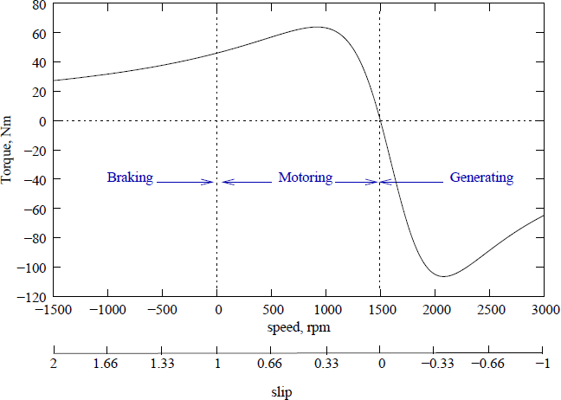

# Effect of Rotor Resistance on Speed TorqueCharacteristic

Restricting ourselves to positive values of slip, we see that the curve has a peak point. This is the maximum torque that the machine can produce, and is called as stalling torque. If the load torque is more than this value, the machine stops rotating or stalls. It occurs at a slip ˆs, which for the machine of Fig: 3.19 is 0.38. At values of slip lower than ˆs, the curve falls steeply down to zero ats=0.Thetorqueatsynchronousspeedisthereforezero.Atvaluesofsliphigherthans=ˆs,the curvefallsslowlytoaminimumvalueats=1.Thetorqueats=1(speed=0)iscalledthestarting torque.Thevalueofthestallingtorquemaybeobtainedbydifferentiatingtheexpressionfortorque withrespecttozeroandsettingittozerotofindthevalueofˆs.Usingthismethod,wecanwrite

–

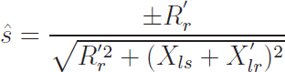

Substituting ˆs into the expression for torque gives us the value of the stalling torque ˆ Te,

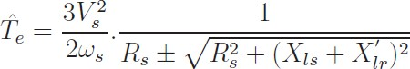

- The negative sign being valid for negativeslip.

The expression shows that ˆ Te is the independent of R′r, while ˆs is directly proportional to R′r. This fact can be made use of conveniently to alter ˆs. If it is possible to change R′r, then we can get a whole series of torque-speed characteristics, the maximum torque remaining constant allthe while.

We may note that if R′r is chosen equal to =



The ˆs, becomes unity, which means that the maximum torque occurs at starting. Thus changing

of R′r, wherever possible can serve as a means to control the starting torque Fig.

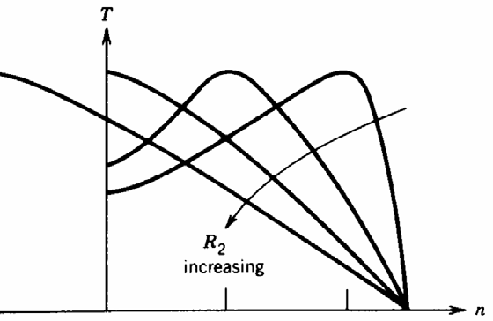

While considering the negative slip range, (generator mode) we note that the maximum torque is higher than in the positive slip region (motoring mode).